# Team K.A.R. HW 8

# Project Brief

**Goals:** Enhance teacher-student interactions and relationships in order to improve both the teacher’s and the student’s experience.

**Audience:** Middle school students (6th-8th grade) and their teachers who realize the importance of establishing improved relationships between teachers and students. The attributes of the students include a desire to have fun and express themselves, and the ability and the general worldview of 12-14 year old Americans. The attributes of the teachers include the aspiration to improve the lives of their students and see the impact that they make, the need to balance their own conception of what is best for the child with the child’s conception of their own world, and the ability of a trained professional.

**Principles:**

There are 3 key constraints that we must keep in mind for a successful production of this product:

First and foremost, our design must be youth-friendly in terms of aesthetics and vocabulary, and easily-accessible, intuitive & usable so that the students can comfortably interact with the app in a way that is congruous with how they usually interact with their environment and technology.

Second, our design must contain different UIs for different target groups so that it can *efficiently* address different problems and goals for the different target groups. In each case the design of the UI needs to be based both on the the goals of each group, as well as the attributes that were listed in the audience section above.

Third, our design must respect the privacy and confidentiality rights of our target users. We must be particularly mindful that these rights and restrictions are more extensive in the case of children and thus we must ensure that our app does not infringe upon these rights.

**Scenario:**

A 7th grade female student recently lost her grandmother when she passed away last week. She has difficulty focusing in class and even at home, where she is constantly reminded of the absence of her grandmother. These challenging personal circumstances make it difficult for the student to interact with her peers and teachers. However because of a new app that her and her teacher have been using, they have created a strong personal relationship and the teacher is able to both identify the reason for her change in behavior, as well as implement a solution that is relevant to the student’s life. Because of this, the student is better able to deal with her personal circumstances and her academic performance is improved. The teacher’s sense of satisfaction is also greater as they have a deeper connection with the student and can see the difference that their involvement has made.

## Product Concepts

**Product Concept 1: Feels**

**Description**:

An interactive platform for students and teachers to express their moods and feelings to the rest of the class. Before settling down in homeroom in the mornings, students will indicate their moods for the day (with an optional description) so that the teacher can approach an individual differently based on his or her mood. Based on their mood, teachers can have follow-up conversations with each student. This will be a quick indicator for the teacher to pay attention to some students who might experience difficult emotions.

**Population Description:**

This targets both the students and the teachers - both get to express their moods to the class as students understand their peers better and behave appropriately while teachers build a closer relationship with the students (especially those who need attention). In addition, material understanding is assessed more rigorously as students self-evaluate and teachers reflect on their teachings.

**Product Concept 2: Do I get it?**

**Description:**

Online/application platform where students anonymously post questions (related to mental health, material and content covered in class, attitudes or behaviors in class, etc) and other students can also anonymously upvote or downvote certain posts (which can bubble up or down depending on interest) - which can be read by students, teachers, and guidance counselors. There exists a need for a system to allow students openly speak their thoughts and opinions, whether that be as simple as “I don’t understand the pythagorean theorem and its application” or as complex as “The teacher does not respect my thoughts in class” or “There are bullies in the classroom.” This will give a chance for everyone to not only express their minds but also see what other students are struggling with and potentially identify problems or struggles, both inside and outside the classroom.

**Population Description:**

This targets both the students and teachers - students get to openly express their thoughts about issues (i.e. mental health, classroom behavior, content, etc) and teachers get to catch unseen or unspoken internal and external issues and brainstorm solutions to solve problems. This can be a safe space for students, and even guidance counselors will get a chance to examine the classroom dynamic.

## 

## Artifacts for Product Concepts

Artifact for Product Concept 1: <https://projects.invisionapp.com/freehand/document/oBhFlf0n8>

Student Interface:

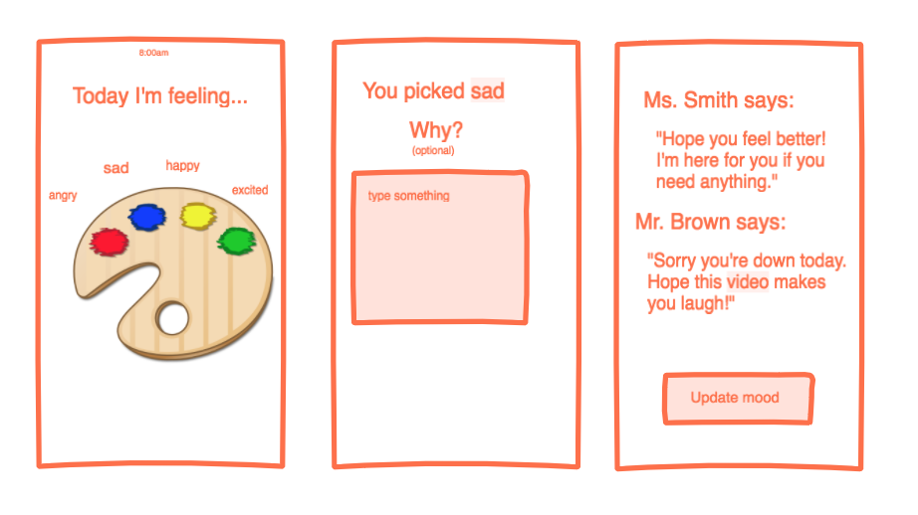

Teacher Interface:

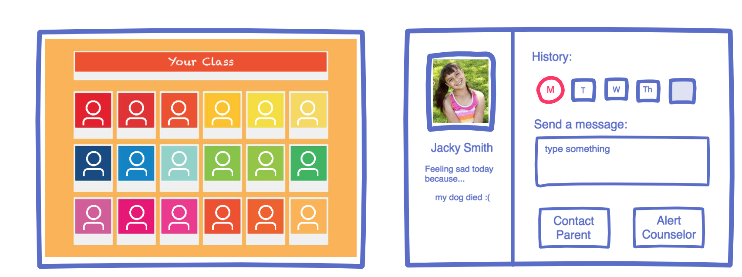

Artifact for Product Concept 2: <https://freehand.invisionapp.com/freehand/document/EA19Ieu0a>

Student Interface:

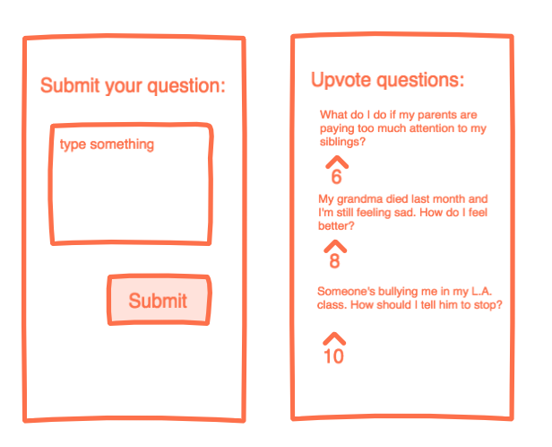

Counselor Interface:

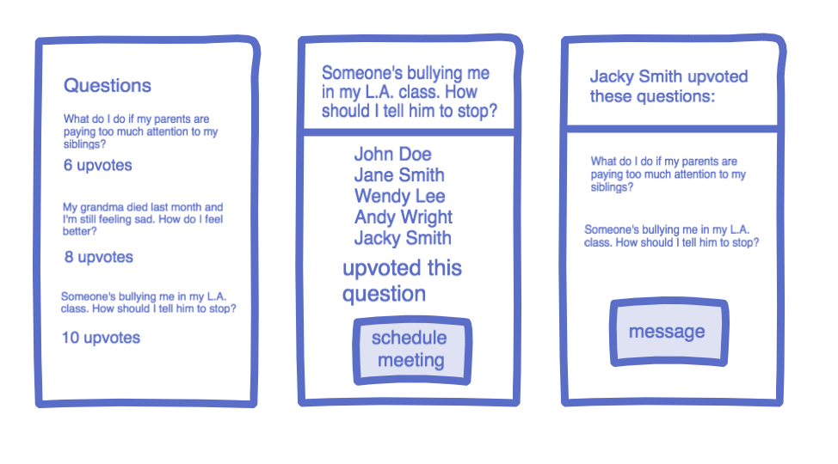

## 

## User Feedback

**Summary of User Feedback 1:**

**Who**: Nicky, 6th and 7th grade science and math teacher

**Where**: Harvard Graduate School of Education

**What**: Interview with attitudinal questions and comment on both prototypes

**Product Concept 1:**

**Evidence** for Product Concept 1: “I wanted to be a teacher because of the relationships with students. Four years later, I didn’t have any strong relationships with them.” “To try and bolster relationships, I would ask myself ‘Who haven’t I talked to this week?’ It would be a good week if I could talk to all 30 students by the end of the week.” “I like this because I could take 10 seconds and know where the kids are at.

**Strengths** for Product Concept 1: Low lift on both student and teacher end to input information and understand information. There is high need for developing relationships in schools and teachers definitely want more opportunities to do so. She preferred this product concept because it would be low input from users and high impact.

**Improvements** for Product Concept 1: For the second screen where students are asked details about their mood, it’s important that it remains optional. It would also be helpful if there were multiple choice options for reasons to pick 3 words instead of writing paragraphs. That way, it’s easier for teachers to read and students will be more willing to input more information. Comments from teachers could have default for all students and default for each student. That way, there’s an easy opportunity for community-building through inside jokes. There could also be a page for administration or principals so they could see the system-level information to perhaps add incentives during low-mood days.

**Product Concept 2:**

**Evidence** for Product Concept 2: “At the end of the day, school is a place to build community, not learn” “This product can help to build safety, love, and trust.”

**Strengths** for Product Concept 2: Students need more counselling and could be hesitant to reach out to counselors on their own.

**Improvements** for Product Concept 2: There would need to be a lot of training to build community and trust in order for small group counselling to work. There should definitely be an option for students to keep questions anonymous if they aren’t comfortable doing small group counselling. This product idea requires a lot more input from students and work for counsellors to act on it. In middle schools, there isn’t enough counselors and time to do this effectively.

**Summary of User Feedback 2:**

**Who**: Kendrick, 5th Grade English Teacher

**Where**: Harvard Graduate School of Education

**What**: Interview with attitudinal questions and comment on both prototypes

**Product Concept 1:**

**Evidence**: He stressed that teachers “don’t have downtime” and thus would find it difficult to respond to children in real time. He also said that they would feel bad simply giving “canned responses” to kids who were struggling, but wouldn’t have the time to write anything longer. He suggested that this could be more effective for an “advisory” in a study hall. He pointed out that middle school children often have a limited capacity of expressing how they feel. He felt that fewer options were polarizing i.e. most kids would just respond “fine” etc. He suggested a wider range of emotions such as “tired”, “lonely”, that would help the students to articulate their feelings. He also suggested that this could be conveyed with emojis, with descriptions of what each emoji means. He emphasized that the teacher UI needs to be quick to use. He really liked the teacher UI graphic of the classroom as it “allows the teacher to glance at it and still get a lot of information”. He thought any idea that included phones in class would not be ideal as teachers don’t like this and it’s hard to control. He suggested that an ideal use case of this could be during homeroom at the start of the day and again in homeroom at the end of the day. He recommended we research ClassDojo for some ideas in terms of UI. He used it with his students and the children loved it. He attributed this to the fact that it was “gamified”.

**Conclusions on Strengths and Weaknesses**: Strengths: It is quick to use for both the teacher and the students. It conveys important information in real time. It increases the ease of 1-1 communication between students and the teacher. There is a clear ideal use case for it i.e. during homeroom periods. Weaknesses: It doesn’t allow or encourage the child to express their feelings fully. It is unrealistic to expect the teacher to respond to comments in real time. Deeper topics of conversation require more time than simply typing out a “canned response”.

**Product Concept 2:**

**Evidence:** “Biggest issue is getting the students to buy in”. In a class situation, the children know each other well enough that it is likely that they could work out who asked which question. This might discourage students from posting. Therefore he recommends a 1-1 interaction between the children and the teacher He points to “shame” as being a big factor in why children don’t share personal issues. This should inform our thinking if we are trying to increase buy-in. He asked if students would have the option of commenting on other questions. He stressed that we should keep in mind the desired use case i.e. he could see this working if the students input and upvote the questions the night before and then the home room teacher discusses them the next day. Another big issue that he brought up was how the process would affect students whose questions had not been upvoted much. He pointed out that the students with unique issues tended to need more support/validation of those issues, yet this system encourages validation of the most common issues.

**Conclusions on Strengths and Weaknesses**: Strengths: There is an ideal use case for this i.e. children posting after school, teacher moderating after school, and then group discussion the next day. The upvoting system means that the problems affecting the most kids get addressed i.e. time is spent efficiently. Weaknesses: It is difficult to convince the students that they will not be associated with their posts, as specific parts of the question they ask could identify them to their classmates. It does not deal with the “shame” that students feel that stops them from speaking to adults directly. It could discourage students whose questions don’t get upvoted as it will seem as if their problems are “less important”, even though the least common problems could often be the most serious.

## **4. Final product concept**

Based on the feedback, develop your final product concept. You can simply pick one of your concepts and revise, merge the two concepts, or devise something entirely new.

**Submit** for your final product concept:

1. Product name
2. A 1-2 paragraph description of the product concept. Clearly state what the product does and what benefit it provides to the users
3. Brief description of the population the concept targets. If there are multiple stakeholders, list them explicitly.
4. If you have materials that you’d like to share in studio to better explain your concept, attach them to your submission. This is helpful especially if your concept is hard to describe in words, but is not required. An sketch or two is fine, you do not need a full prototype.

**Product Name**: Feels

**Concept Description**:

For many teachers, they enter into the profession because of wanting to develop relationships with students. However, their job involves many more aspects: creating curriculum, grading tests, delivering content, aligning to state standards, and working with other teachers. To facilitate the student-teacher relationship process, we created Feels to streamline the communication process. At a glance, teachers can see the spectrum of emotions and moods their students have in a given day. From this initial information, teachers can initiate conversations to further develop their relationships with students.

**Populations**: Middle school students and teachers

**Materials**: <https://projects.invisionapp.com/freehand/document/oBhFlf0n8>

Student UI:

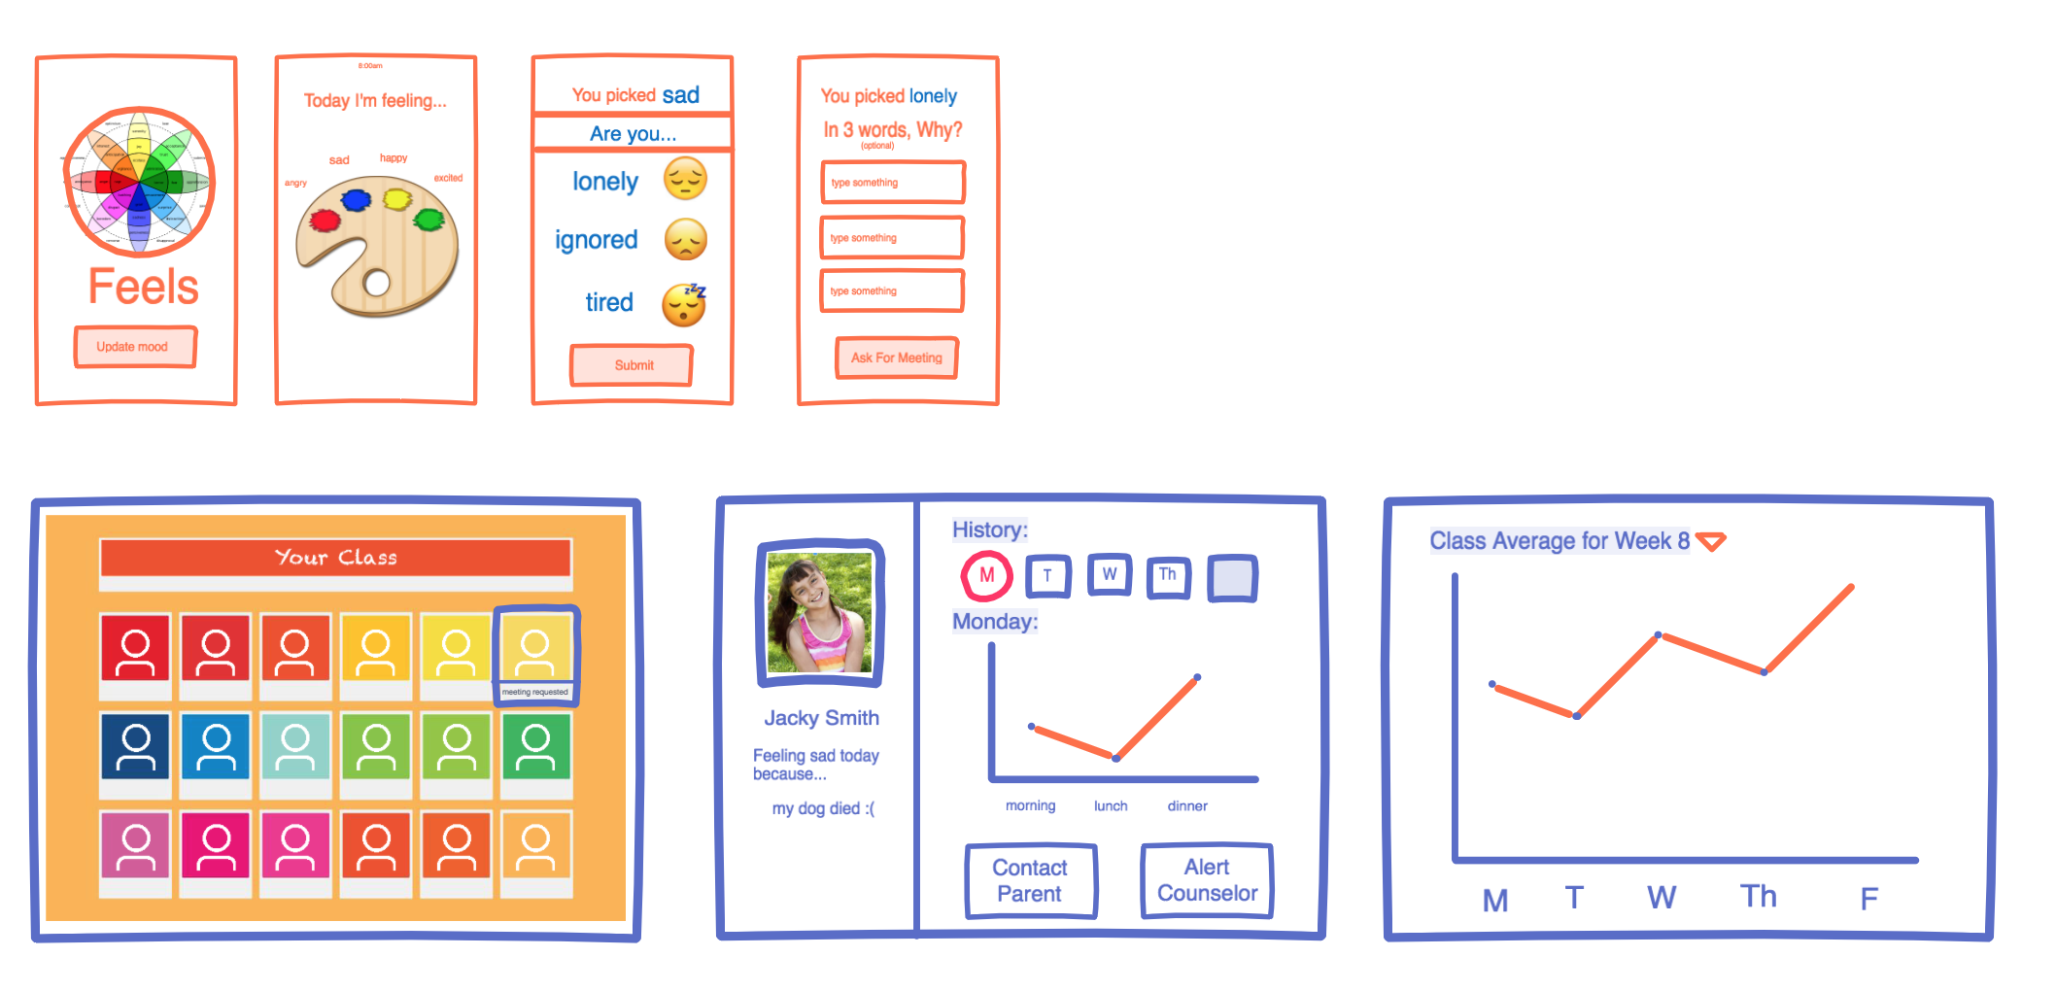

Teacher UI:





Section Feedback:

* Maybe display all types of “sad” in the first screen so you know the options
* Would middle schoolers troll this? How to react to that.
* Class view could have a spectrum of colors as well similar to Plutchik’s wheel
* Do all middle schoolers have smartphones
* If a student doesn’t, how will they deal with this. - maybe using another student’s phone
* Kids might not want teachers to know emotions/be truthful
* Ask for meeting button expects too much of students, better if it’s teacher’s option
* Is there a more indirect way to gauge a person’s emotion - choose images, songs etc.
* Could make sense with connection with homework/academics
* Different Socio-economic areas could have different capabilities/priorities

Research on Smartphones in Middle Schools:

<http://www.growingwireless.com/get-the-facts/quick-facts>

**Children and Cellphones**

* On average, children are 12.1 when they receive their first mobile device. [[Source]](http://www.att.com/gen/press-room?pid=22917)
* 56 percent of children, age 8 to 12, have a cellphone. [[Source]](http://www.nclnet.org/newsroom/press-releases/681-survey-majority-of-tweeners-now-have-cell-phones-with-many-parents-concerned-about-cost)
* 60 percent of families who have provided a cellphone to their child did so between the ages of 10 and 11. 20 percent provided their 8 to 9 year olds with a cellphone. [[Source]](http://www.nclnet.org/newsroom/press-releases/681-survey-majority-of-tweeners-now-have-cell-phones-with-many-parents-concerned-about-cost)
* Among children 8 years of age and younger, 21 percent use smartphones. [[Source]](http://web5.soc.northwestern.edu/cmhd/wp-content/uploads/2013/05/Parenting-Report_FINAL.pdf)
* 69 percent of families with young children under 8 years old have a smartphone. [[Source]](http://cmhd.northwestern.edu/parenting-in-the-age-of-digital-technology/)
* 38 percent of children under 2 used a mobile device for media. [[Source]](https://www.commonsensemedia.org/research/zero-to-eight-childrens-media-use-in-america-2013/key-finding-2%3A-kids%27-time-on-mobile-devices-triples)
* Dads are more likely to give kids smartphones in elementary school while moms are more likely to give kids smartphones in middle school. [[Source]](http://sprint.co/1E3Z0Cd)

**Education:**

* 74 percent of teachers say that technology enables them to reinforce and expand on content. [[Source]](http://www.pbs.org/about/news/archive/2013/teacher-tech-survey/)
* 74 percent of teachers say that technology motivates students to learn.[[Source]](http://www.pbs.org/about/news/archive/2013/teacher-tech-survey/)
* 73 percent of teachers say that technology helps them respond to a variety of learning styles. [[Source]](http://www.pbs.org/about/news/archive/2013/teacher-tech-survey/)
* 69 percent of teachers say that technology allows them to "do much more than ever before" for their students. [[Source]](http://www.pbs.org/about/news/archive/2013/teacher-tech-survey/)
* 35 percent of teachers have access to a tablet or e-reader in the classroom as compared to only 20 percent in 2012. Among teachers with access to tablets:
  + 71 percent cite the use of educational apps as the most beneficial for teaching,
  + 64 percent said educational websites and
  + 60 percent said educational e-books/textbooks. [[Source]](http://www.pbs.org/about/news/archive/2013/teacher-tech-survey/)
* More than 50 percent of parents said schools should make more use of mobile devices for education. [[Source]](http://www.grunwald.com/pdfs/Grunwald%20Mobile%20Study%20public%20report.pdf)
  + 32 percent of parents believe they should be required in the classroom.
  + 71 percent of parents believe mobile devices open up learning opportunities.
  + 62 percent of parents believe mobile devices benefit students' learning.
  + 59 percent of parents believe mobile devices engage students in the classroom.
* 45 percent of parents say they plan to buy, or already have bought a mobile device to support their child’s learning. [[Source]](http://www.grunwald.com/pdfs/Grunwald%20Mobile%20Study%20public%20report.pdf)
* 68 percent of parents agree that mobile devices and apps can help teach reading. 67 percent think they can help teach math. [[Source]](http://www.grunwald.com/pdfs/Grunwald%20Mobile%20Study%20public%20report.pdf)
* 43 percent of parents say they need help finding educational apps. [[Source]](http://www.grunwald.com/pdfs/Grunwald%20Mobile%20Study%20public%20report.pdf)
* Only 27 percent of high school principals report they are not yet offering any online courses for students. [[Source]](http://www.tomorrow.org/speakup/SU14DigitalLearning24-7_StudentReport.html)
* 46 percent of students see smartphones as the ideal device for communicating with teachers.[[Source]](http://www.tomorrow.org/speakup/SU14DigitalLearning24-7_StudentReport.html)
* 86 percent of principals say that students using mobile devices to help with school work is important. 50 percent said “very important.” [[Source]](http://www.edtechmagazine.com/k12/article/2015/05/survey-mobile-devices-rule-students-teachers-infographic)
* 75 percent of K-12 students say it is important that they have access to their mobile devices at school. [[Source]](http://www.edtechmagazine.com/k12/article/2015/05/survey-mobile-devices-rule-students-teachers-infographic)

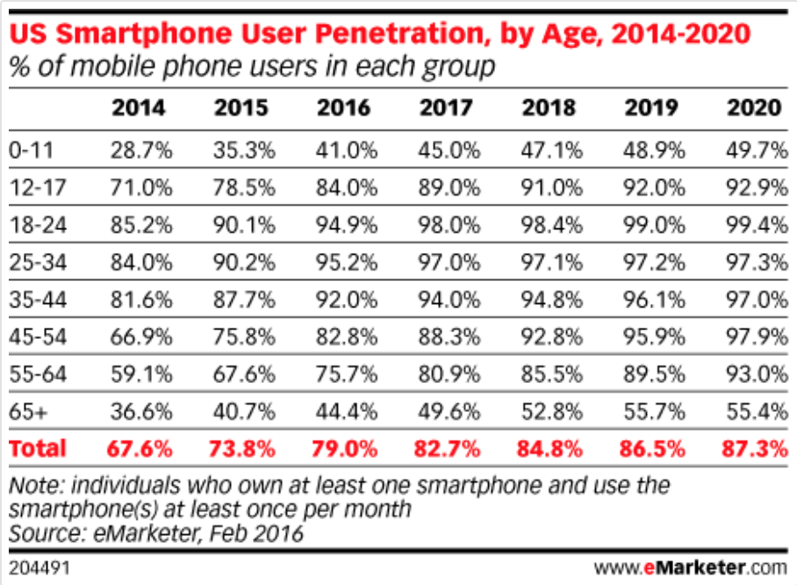

<https://www.emarketer.com/Chart/US-Smartphone-User-Penetration-by-Age-2014-2020-of-mobile-phone-users-each-group/185565>